INSTRUCTION MANUAL FOR ROLLER MIXER
Power indicator
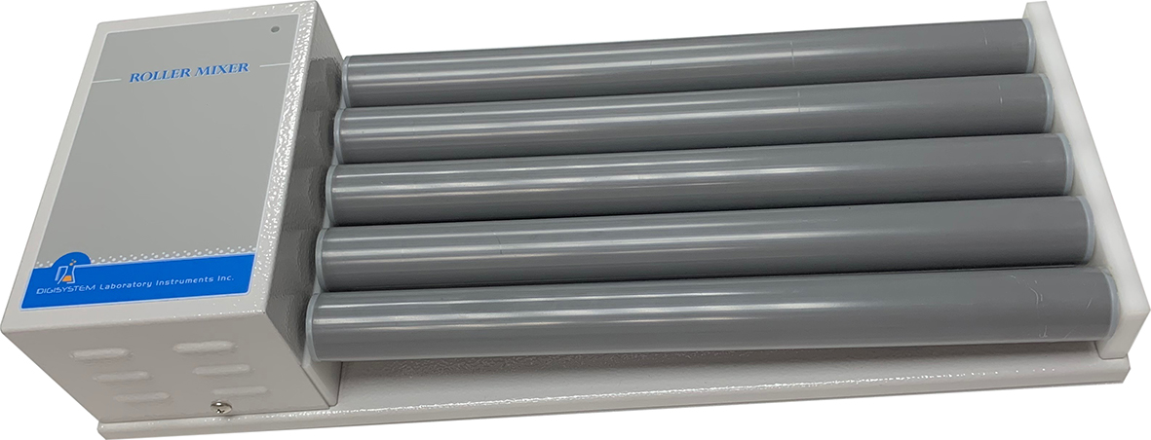
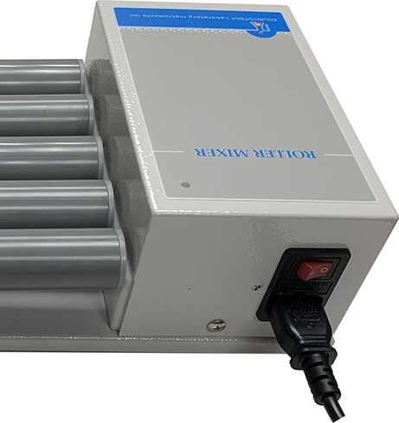

ON/OFF Switch

Power socket
Rollers

Warnings:
* Do not remove the mixer during operation.
* Place the mixer securely away from the edge of bench to avoid the mixer falling off the bench top.
* Do not disassemble the mixer by yourself. In the event of a malfunction, the mixer should be repaired by a qualified technician. Before repairing, turn off the power.

Steps:
- Place the mixer on a flat and stable bench top. Connect cable with power socket and a properly grounded outlet which corresponds with the electrical requirements on the label back on machine.
- Put the specimen into a container and tight closed , and then place the container between ‘Rollers’.
- Place ‘ ON/OFF Switch’ at ‘ON’ position, and then the power indicator is illuminated. Then the machine starts rolling.
- Containers can be loaded and unloaded during the machine rolling.

Maintenance and care:
Keep the machine clean all the time, so no routine maintenance is required. Cleaning can be done with a damp cloth. Avoid the use of solvents as they may damage the machine housing.

Circuit Diagram

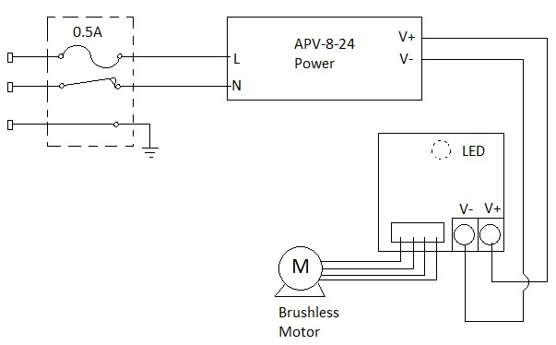

Troubleshooting Guide
Caution: Always disconnect the power cord before troubleshooting.
Trouble | Cause | Remedy
Instrument inoperative | Power cord not connected to outlet. | Plug in the power cord.
Instrument inoperative | Dead power output. | Change to different output.
Instrument inoperative | Fuse blown. | Change a new fuse.
Instrument inoperative | Defective electronic component. | Contact your distributor for repair.
Rollers doesn’t rotate | Switch is at “OFF” position. | Place the switch at “ON” position.
Rollers doesn’t rotate | PC board is broken. | Contact your distributor for repair.
Rollers doesn’t rotate | Motor is broken. | Contact your distributor for repair.
Rollers doesn’t rotate | Switch is broken. | Contact your distributor for repair.
Rollers doesn’t rotate | Drive pully oiled on the rubber ring. | Contract your distributor for cleaning up the oil.
Rollers doesn’t rotate | Rubber ring is broken. | Contact your distributor for repair.
Rollers doesn’t rotate | Plastic fixer for driven pulley is broken. | Contact your distributor for repair.
Rollers doesn’t rotate | Plastic gear is broken. | Contact your distributor for repair.
Rollers doesn’t rotate | The motor, plastic gears, and rollers don’t joint well. | Contact your distributor for repair.

